**1. List countries with income level of "Upper middle income".**

There are 55 total countries with an income level of ‘Upper middle income’.

**2. List countries with income level of "Low income" per region.**

There are 27 countries with income level of ‘Low income’. Of these, 23 are in ‘Sub-Saharan Africa’, 2 are in ‘Middle East & North Africa’ and 1 in each of ‘South Asia’ and ‘East Asia & Pacific’.

**3. Find the region with the highest proportion of "High income" countries.**

The region with the highest proportion of ‘High income’ countries is North America. All 3 of the countries in North America have income level of ‘High Income’.

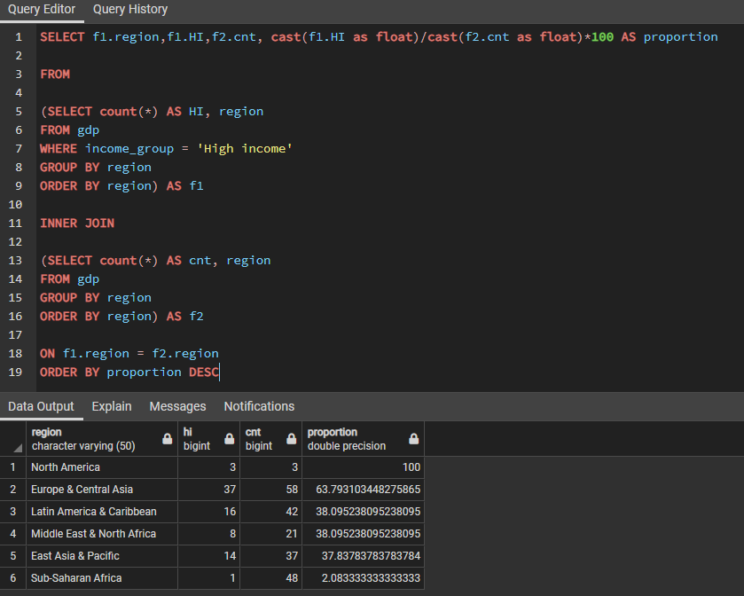

**4. Calculate cumulative/running value of GDP per region ordered by income from lowest to highest and country name. (2017 onwards)**

Cumulative GDP for 2017 – 2020 has been calculated per region, and ordered from lowest to highest. Unsure as to what the question means when it asks to order by country name too as data has been grouped ‘per region’. COALESCE function has been used so that NULL is treated as 0.

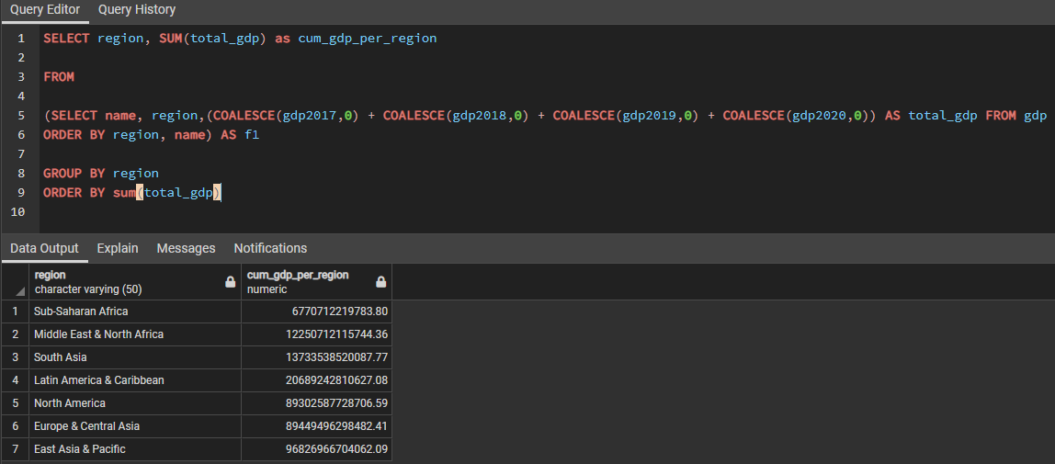

**5. Calculate percentage difference in value of GDP year-on-year per country.**

Percentage difference in value has been calculated for every country. Where one or more values were NULL, a percentage difference is not possible to calculate and so NULL is displayed.

**6. List 3 countries with lowest GDP per region. (2017 onwards)**

Since the question asked to use 2017 data onwards, I found the minimum value of GDP per country (min_gdp) for any of the years (2017,2018,2019,2020). This was because many countries had data missing for some years and it would therefore not make sense to total the GDP over these years.

Once the minimum was found, I then ordered these by region and min_gdp and used the rank function to rank each country per region. Rank_filter was then used to select only 3 countries per region.

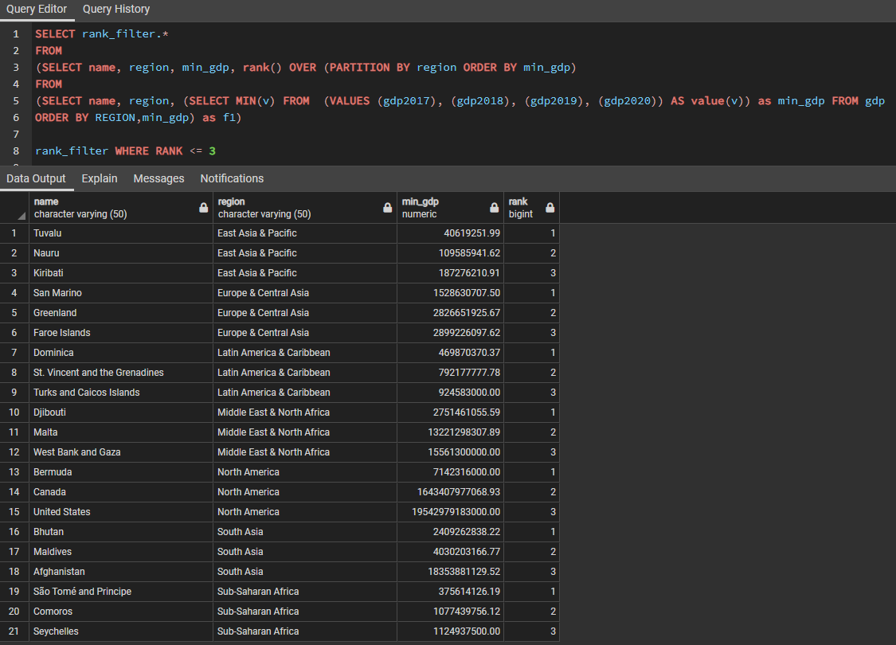

**7. Provide an interesting fact from the dataset.**

Over the course of 2017 – 2020, the United States had a higher GDP than that of all the 'Sub-Saharan Africa', 'Middle East & North Africa', 'South Asia' and 'Latin America & Caribbean' regions combined (total of 119 countries).

**Combined regions GDP - $53444205666243.01**

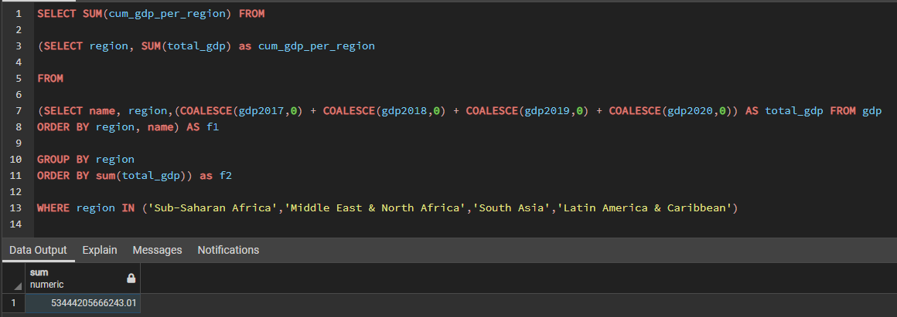

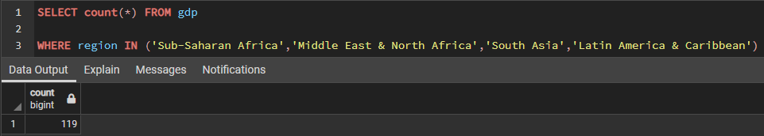

**USA GDP - $82524664814000.00**

